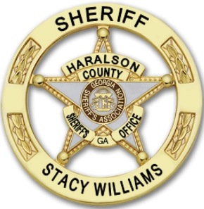
Haralson County Sheriff’s Office
Sheriff Stacy Williams

Affidavit for Requesting Booking Photos
According to O.C.G.A 35-1-18 (effective July 1, 2014), it is unlawful for any person or business to post, publicize, upload, or transmit a booking photograph of an arrestee to any website or electronic media which charges a fee or other consideration for the removal of said photo. It is also unlawful for any person or business to otherwise cause the same actions as intended above, by any other similar means or verbiage.

Before any person can obtain a booking photograph of an arrestee, he or she must sign complete and submit this statement affirming the use of such compliance in accordance with O.C.G.A. 35-1-18. Furthermore, any person who knowingly makes a false statement in requesting a booking photograph shall be guilty of a felony – O.C.G.A. 16-10-20 – False Statements and writings.

This statement or affidavit is valid for one year from the date noted herein. Furthermore, this document must be signed by any person or individual requesting information.

________________________________ _______________________________________
Name of Requester Organization represented (if applicable)

________________________________ __________________
Signature of Requester Date

_________________________________________ __________________
Receiving Official (Sheriff’s Office Representative) Date

